ALPINE ASCENTS:

|  |  |  |  |
| --- | --- | --- | --- |
| Supervisor | Ambreen Shamshair Ali | | |
| Batch |  | |
| Group | B | | |
| Serial No | Enrollment No | Student Name | |
| 1 | 1473982 | Ambreen Shamshair Ali | |
| 2 | 1473624 | Zainab Waseem | |
| 3 | 1473625 | Rimsha Hanif | |
| 4 | 1463422 | Wadain Imran | |

Acknowledgment:

Before anything, I would like to thanks my beloved teacher who helped us a lot

in reviewing this project within the limited time frame.

Secondly, we would also like to thank the eProject team at Aptech Head Office,

who gave us the golden opportunity to do this wonderful project about Alpine Ascents

Thirdly, we also thank the eProject team, some of the benefits are as under:

Re-enforcement of skills happens in the experiential learning process. ∙ A

mentor, ensuring that we do not get drifted, constantly guides us. ∙ It gives us a

lot of confidence to face an interview as we have worked on a project.

Synopsis:

With the help of technology, we are providing people ease to book tickets and

Join us in this adventure and experience. We are providing relaxing

survey to our website. Attached all the information about the main activities of

mountains. So shares the perfect relaxing images through the website for

everyone to know. For the convenience of the people we have provided map

for the route. Best mountaineering website to visit.

Problem Definition:

Celebrating 37 years of leading successful expeditions in 2023, Alpine Ascents

International, Inc. is a leader in the climbing industry and has been instrumental in

setting guiding standards in the international climbing community for most of our

history. This year, we will offer more than 30 different expeditions and 50 training

courses in 14 countries, including the Arctic and Antarctic regions.

Aggregated Site Map:

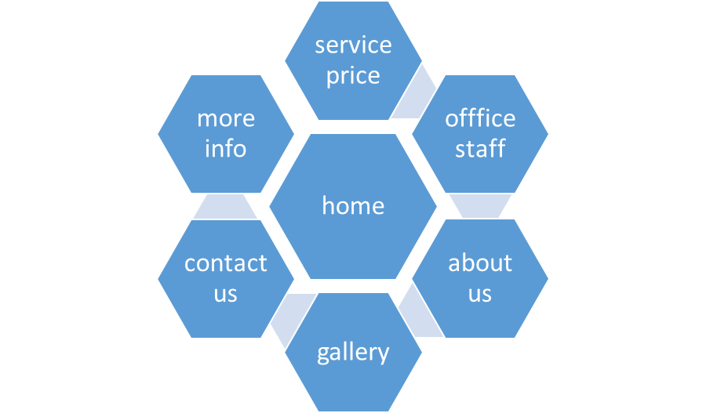

Sitemap English:

Nav bar

Logo home about us gallery contact us more info

Content

Service prices

Office staff

content

picture

picture

picture

picture

heading

About us blogs

picture

picture

picture

Gallery

content

picture

picture

picture

picture

picture

picture

picture

picture

picture

picture

picture

picture

picture

picture

picture

picture

picture

Contact us

content

picture

More info

heading

content

picture

picture

content

content

picture

picture

content

heading

picture

picture

content

content

picture

picture

content

content

Picture

picture

content

content

heading

picture

picture

picture

content

content

co**n**tent

picture

picture

Picture

content

content

content

picture

picture

picture

content

content

content

footer

map

content

logo

logo

logo

button

Content